Broward County Public Schools
Gifted Advisory Council- General Meeting
Plantation Middle School
May 12th, 2025, @ 6:30pm

Email: BrowardcountyGAC@gmail.com Website: http://giftedadvisorycouncil.ch2v.com/

Chair: Karla Figueroa Vice Chair: Alan Bushkin
Recording Secretary: Kay Lewis Corresponding Secretary: Vacant

AGENDA

- Call to Order

- Introductions/ Meeting Etiquette

- Approval of April 2025 Minutes

- Old Business
  - Final Vote for GAC Board for 25/26 School Year
    - Chair- Alan Bushkin
    - Vice Chair- Vaughn Reynolds
    - Recording Secretary- Kadiya “Kay” Lewis (re-elected).
    - Corresponding Secretary-Mirline McDonald

- New Business

  - Summer Camps- ESE Department
  - Topics for 25/26 School Year

- Open Q&A

- Adjourn

Next General Meeting: September 2025

Gifted Canvas Resources: 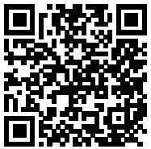 Website: 